POCKET TANK
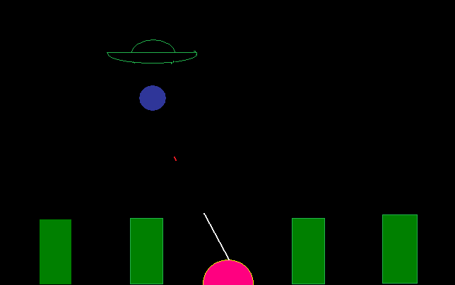

SUBMITED BY :-
SHANTANU SHUKLA (07102188)
AVINAV SHARAN (07102186)
ANKUR GUPTA (07102192)
DEEPAK SHARMA (07102198)
BATCH— A-2
Semester -- II

Lecturer :-
Sandeep Kumar Saxena

ACKNOWLEDGEMENT

It is our pleasure to take this opportunity to sincerely thank all the teachers, senior mentors and friends who all have put forward their helping hand throughout the semester in making us learn understand and apply the subject of data structures in different fields and C language programming.
We won’t have succeeded if the faculty members had not shown their interest in our project.
Now at last we are fully satisfied and proud of ourselves as, we as a group have completed this project on data structures which is a game created by our own imaginations........
Finally, we must thank our lecturer Mr. Sandeep Kumar Singh, our lab evaluators Mrs. Suma Dawn, Mrs. Gagandeep and Mrs. Sangeeta Mittal for being there to solve our problems that we faced during our project.

Shantanu Shukla (07102188) Avinav Sharan (07102186)
Ankur Gupta (07102192) Deepak Sharma (07102198)
INTRODUCTION :

The game known to all..... the game that fascinates all None other than pocket tank........ aim - to destroy the enemy. The game proceeds with an alien spaceship invading a city. Its aim is to destroy all the four buildings with the limited number of bombs. The another part of the game is the opponent tank which aims the bombs to protect the four buildings.

Use Of Graphics :
Graphics has been used for creating objects: spaceships, tank etc.

Data Structures Used :

The main data structures used in the project are link lists and file I/O. The files are used for giving instructions and the history of the game. In fact the file used in the purpose of displaying history is used such when a player plays the game, his score gets stored in that file under his name each time he plays it.
- File :
- Link list :

Various Functions Called :
The following functions are called in the coding for different purposes:
- Void bomb():
The fuction is called to drop the bomb from the spaceship.
- Void together():
This function is called to display both the bombing and firing at the same time. In together function first firing takes place and then bombing.
- Void together1():
This function is also called to display both the bombing and firing at the same time on the screen but here bombing precedes firing by the tank.
- Void fire():
The function is called to fire bullets from the tank on the ground.
- Void rotate_right():
The function is called which rotates the tank’s gun in the right direction.
- Void rotate_left():
The function is called which rotates the tank’s gun in the left direction.
- Void move_right():
The function is called which moves the spaceship in the right direction.
- Void move_left():
The function is called which moves the spaceship in the left direction.
- Void score1():
The function is defined such that for each building destroyed by the spaceship, the player gains 100 points and for each wasted bomb, the player looses 20 points.
- Void score2():
The function is defined such that for each bomb destroyed by the tank in air, the player gains 100 points.

- Void player1():
The function is called for 1 player game, in which the spaceship is set 2 bomb the four buildings of its own.
- Void frame():
This function includes the bottom part of the output screen i.e. the four buildings and the bottom line to

